**Daraz Online Management System**

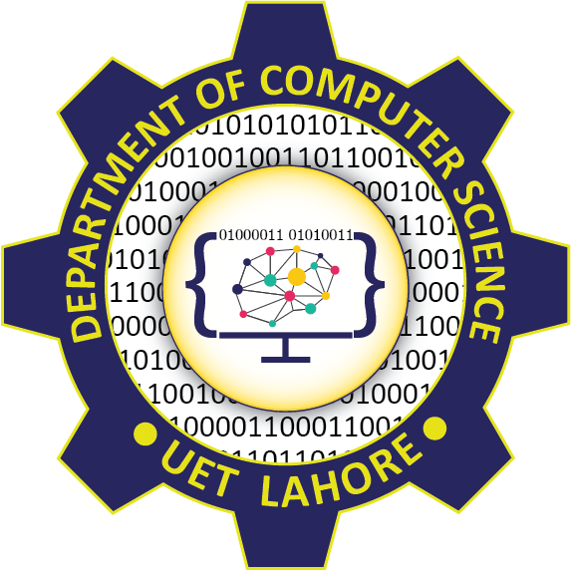

Session: 2021 – 2024

**Submitted by:**

Abdul Mateen 2021-CS-190

**Supervised by:**

Dr. Maida Shahid

Department of Computer Science

**University of Engineering and Technology**

**Lahore Pakistan**